
lab 05_report
Programming paradigms

November 9, 2026
Name: Siem Khattyavatey
Student ID: p20250056
GIT URL: https://github.com/zikkyiscool/PDI.git

Practice 1:
Problem: Write a procedural program to find the sum of even numbers from 1 to 100. Display result on screen.
Solution:
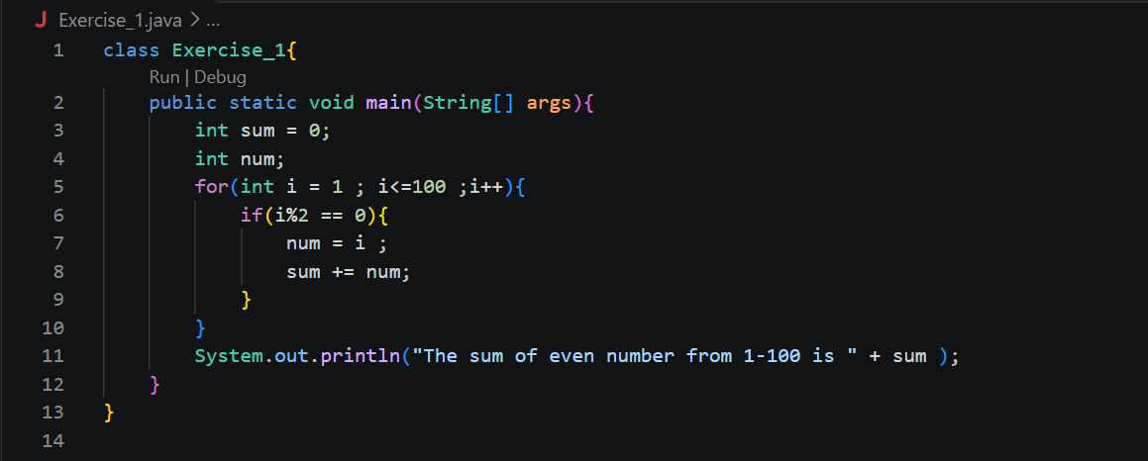
Output:
Practice 2:
Problem: Implement a calculator that supports basic arithmetic operations (+, -, *, /, sum from 1 to n) using a menu-driven approach.
Solution:
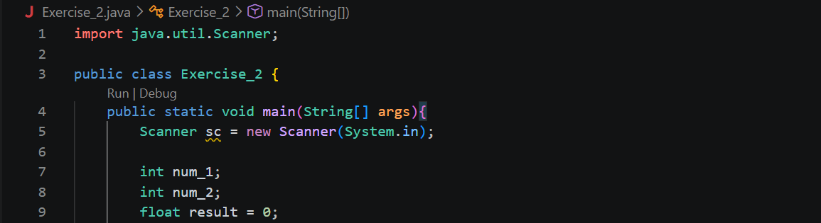
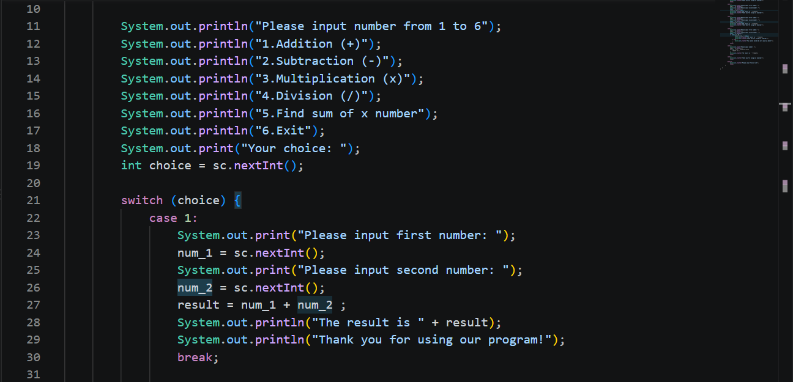
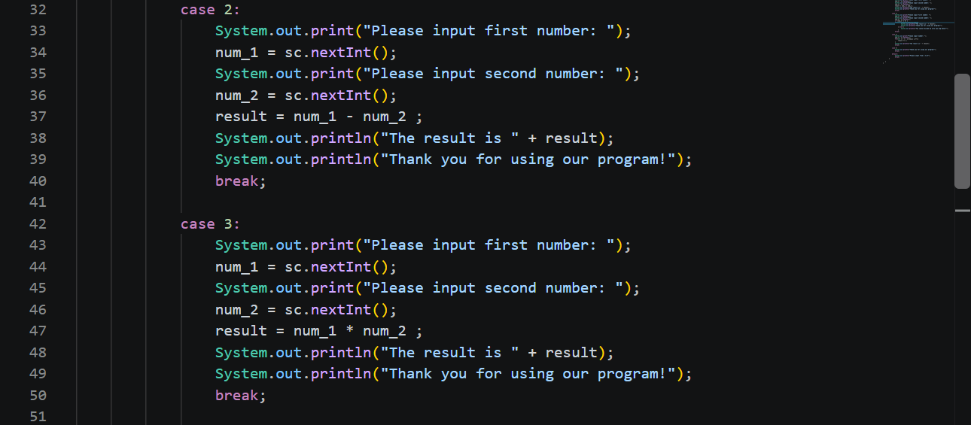

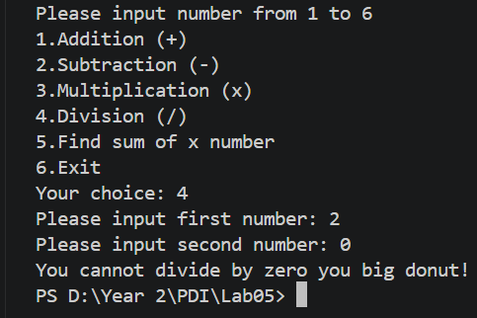
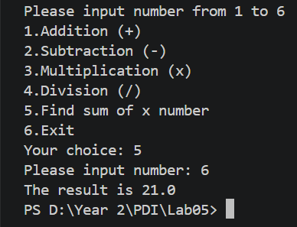
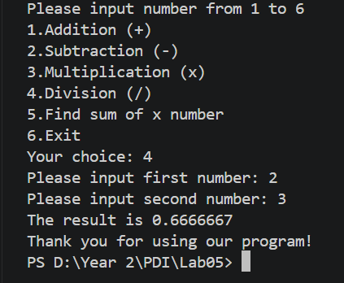
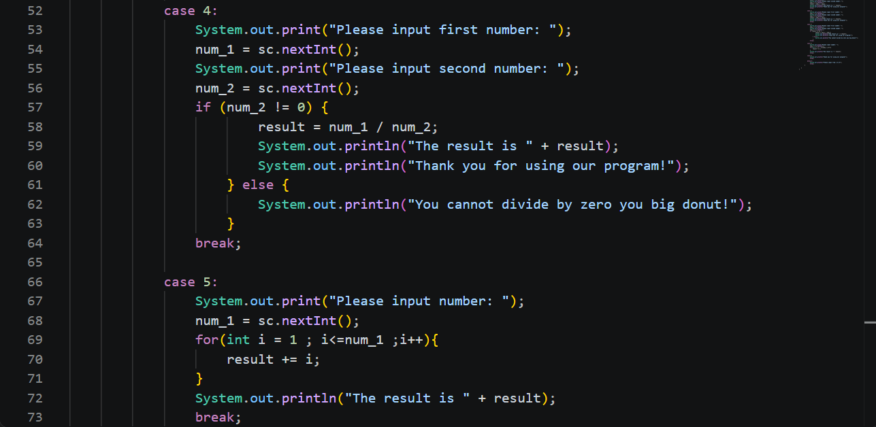
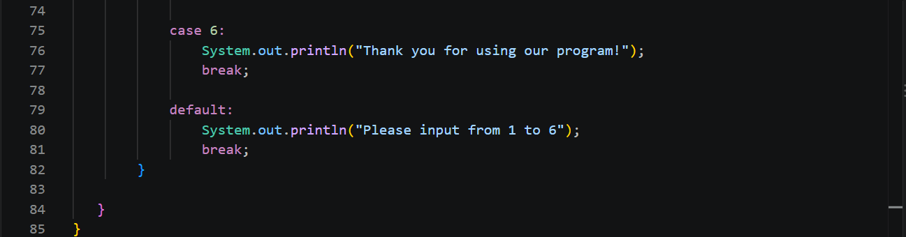
Output:

Practice 3:
Problem: Creates two Book objects using default and parameterized constructors, then displays their title, author, and price.
Solution:
Book.java: Defines attributes, constructors, and display method
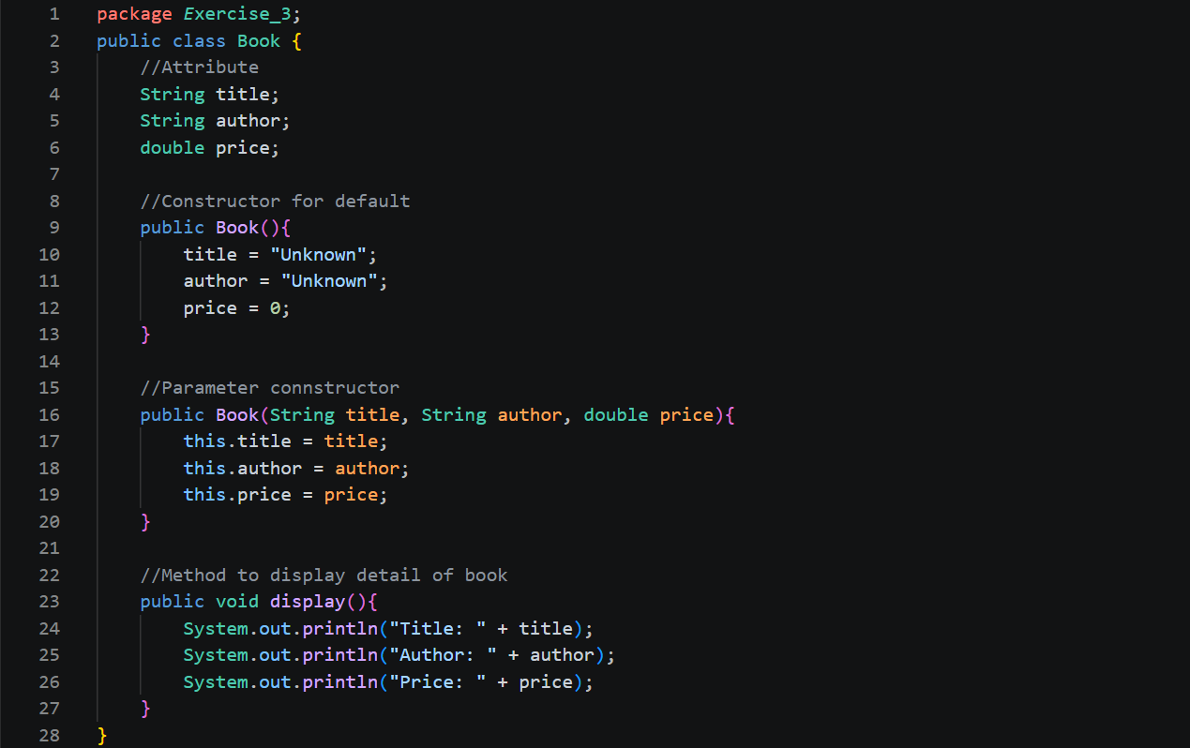
Main.java: Main program creates objects.
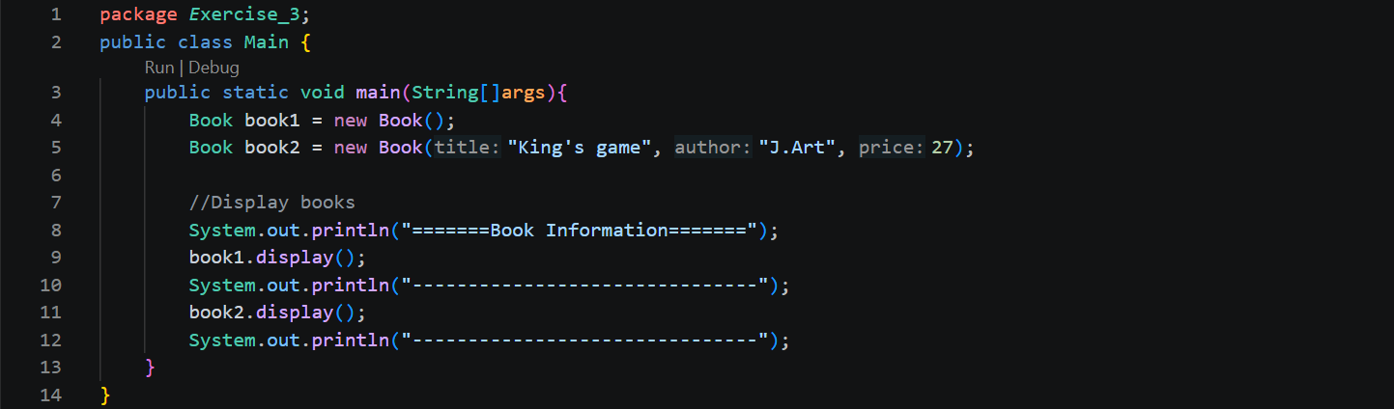
November 9, 2026

Output:
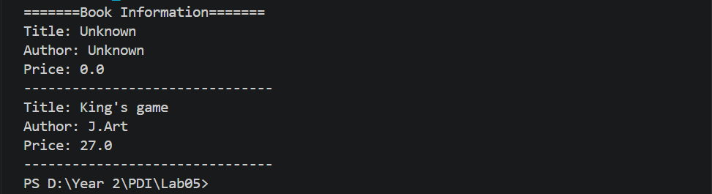
Practice 4:
Problem: Creates an Employee object using a constructor, with getters and setters to access and update its private attributes.
Solution:
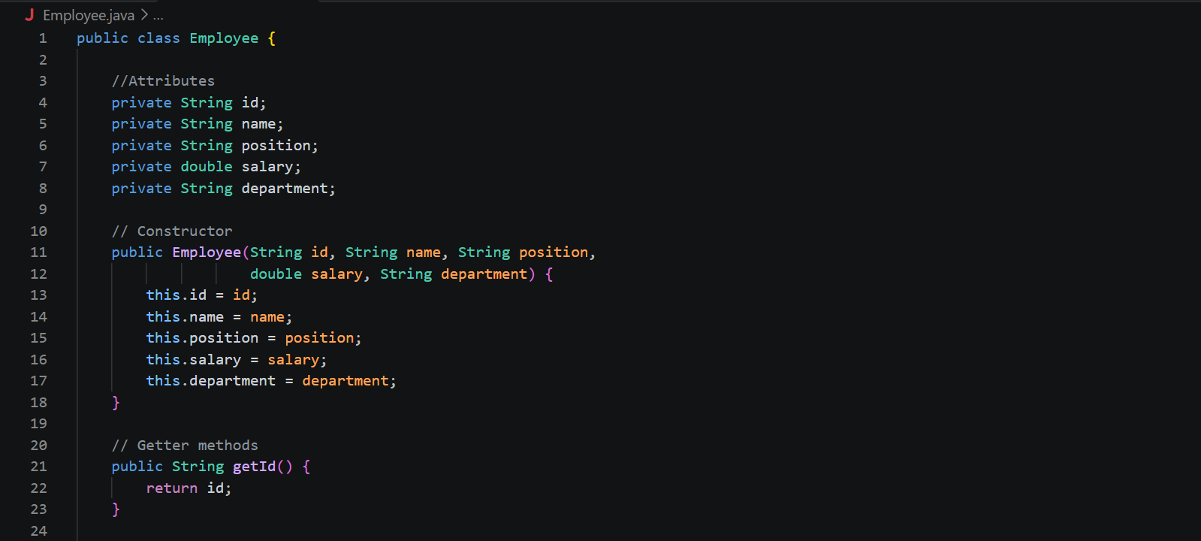
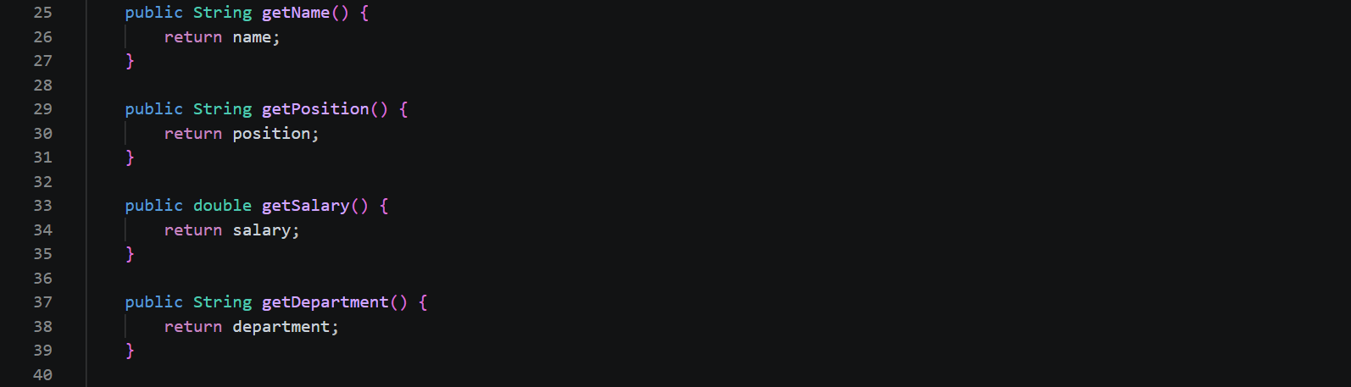
Employee.java: Defines the employee's information and manages its attributes.
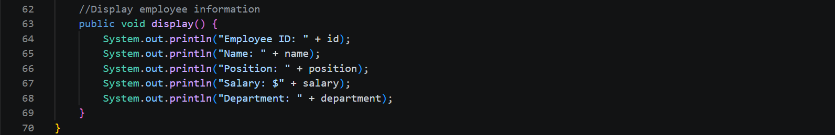
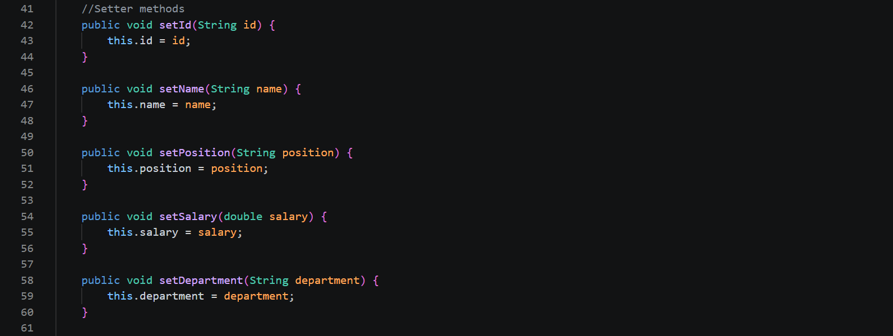
Main.java: Creates and tests the Employee object.
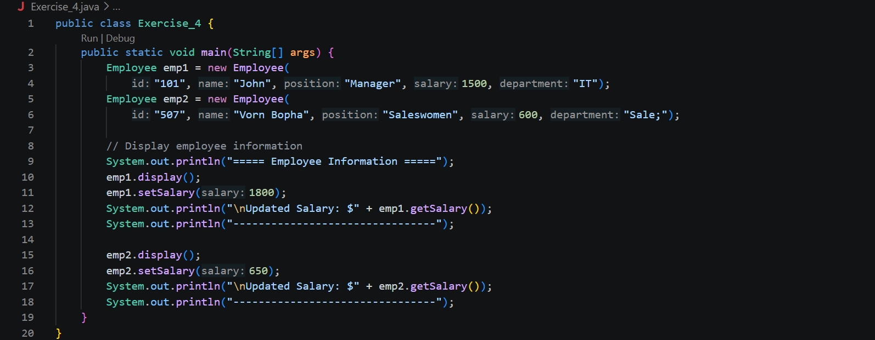
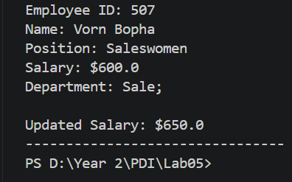
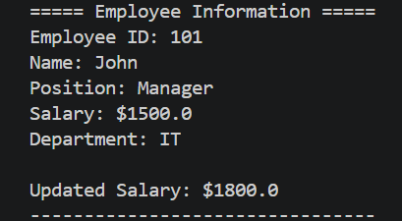
Output:

Practice 5:
Problem: Compare the execution of a factorial function implemented procedurally and using recursion.
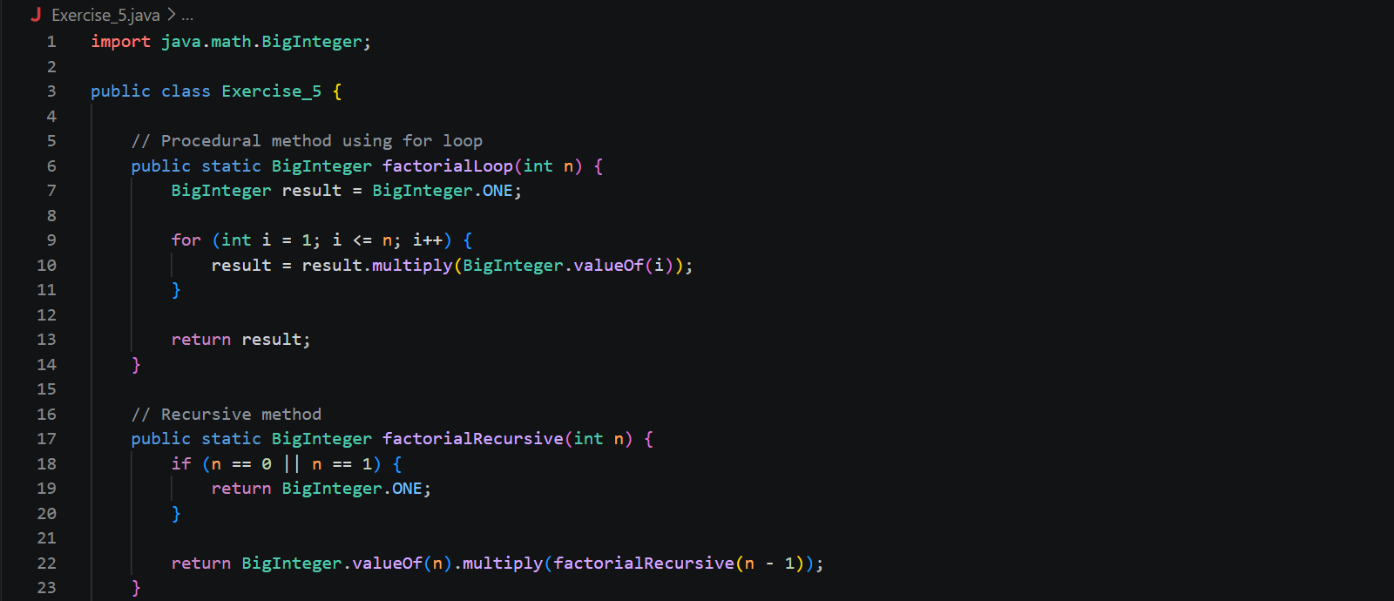
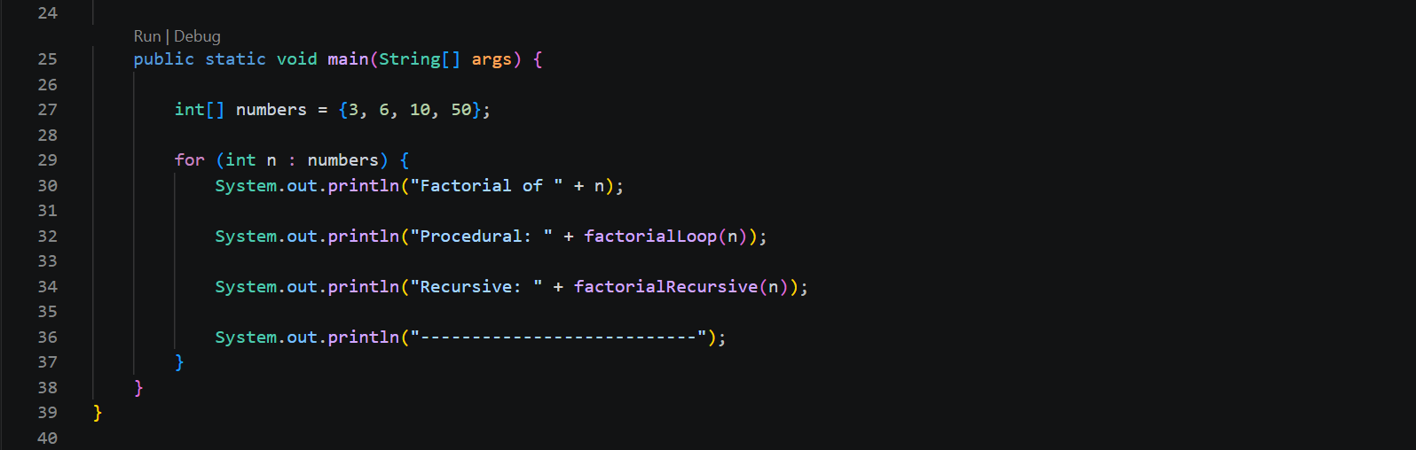
Solution:
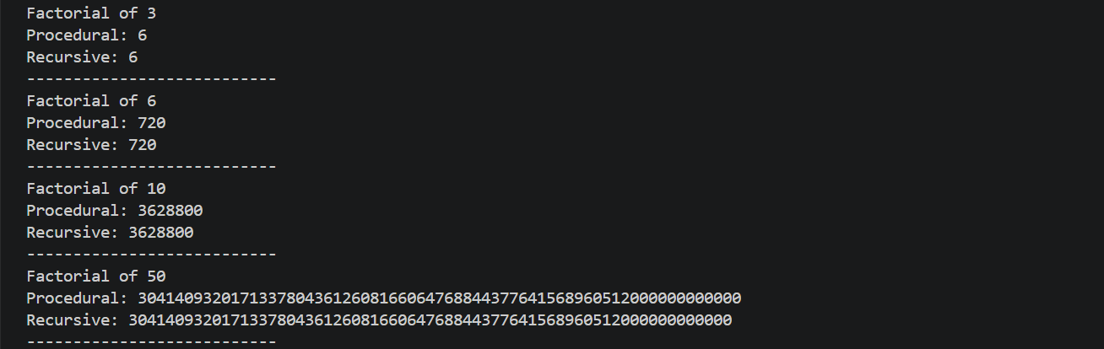
Output:
Practice 6:
Problem: Create Rectangle and Circle classes using encapsulation, constructors, getters, and setters to manage dimensions and calculate area and perimeter.
Solution:
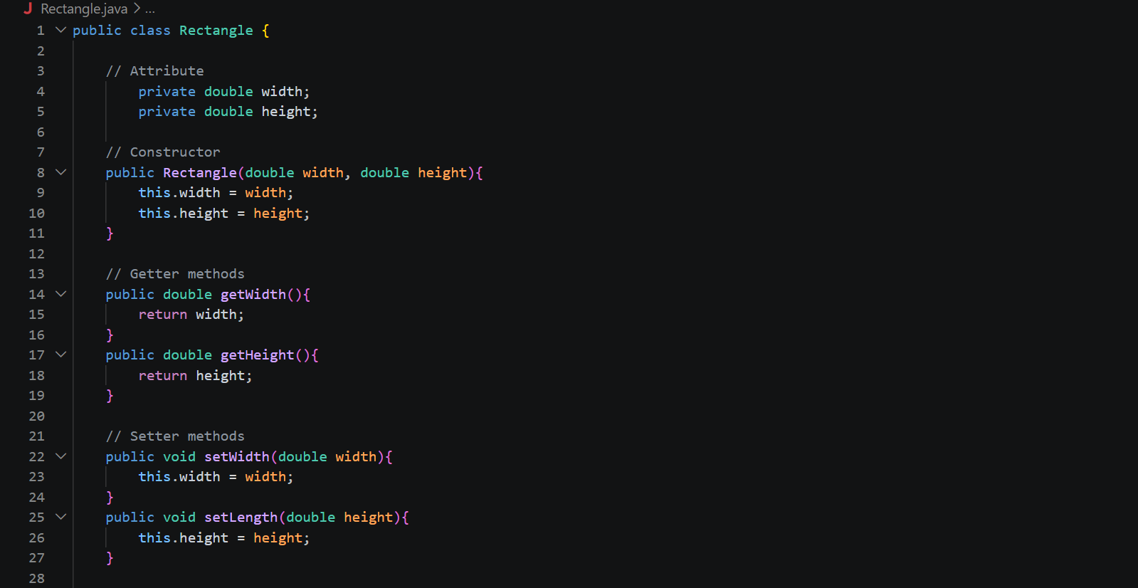
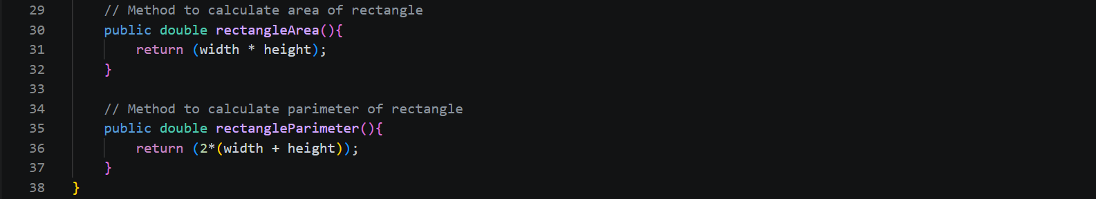
Rectangle.java: Create methods to calculate area and perimeter

Circle.java: Create methods to calculate area and perimeter of circle.
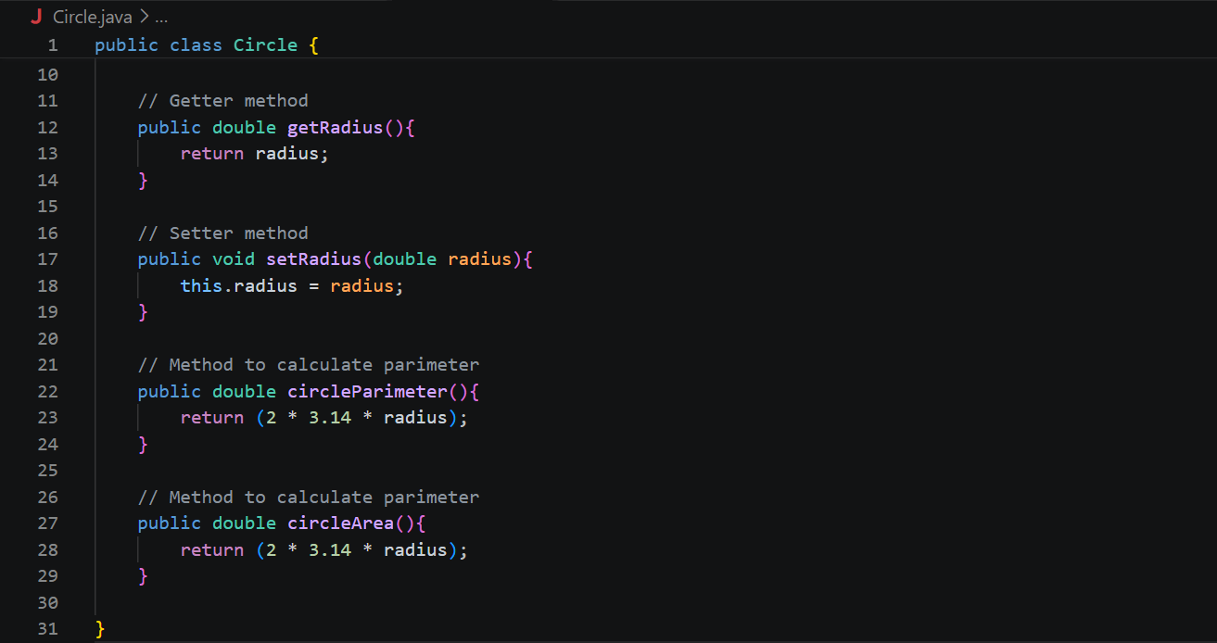
Main.java: Create objects and tests the methods from both classes.
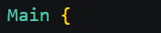
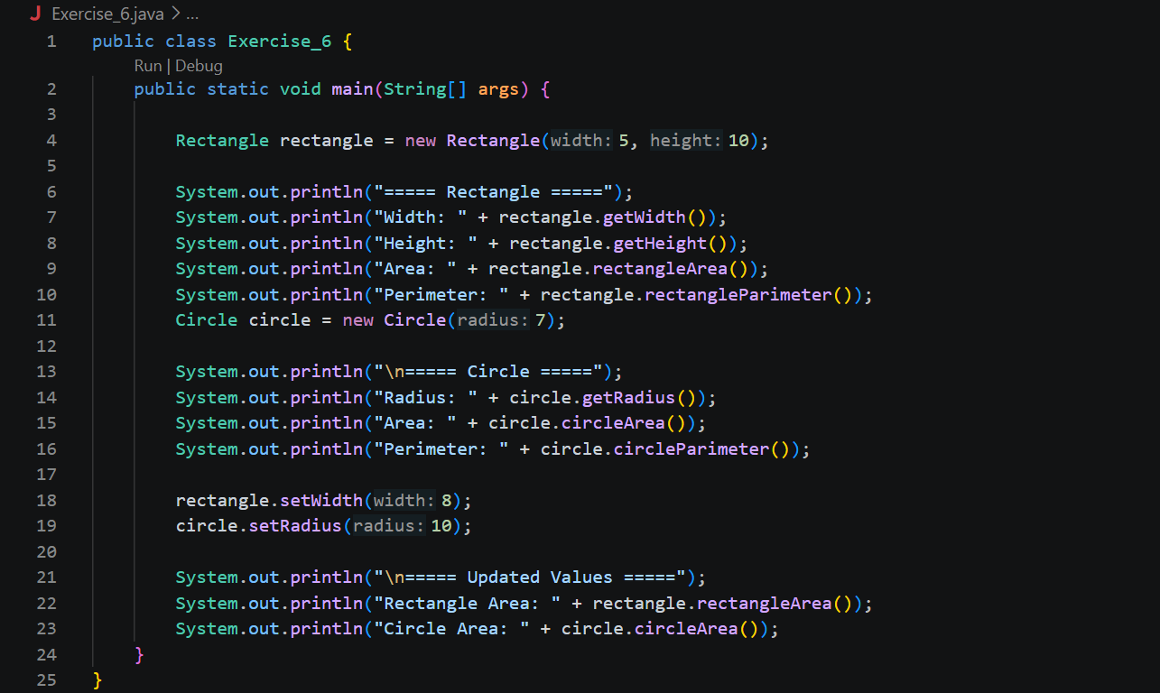

Output:
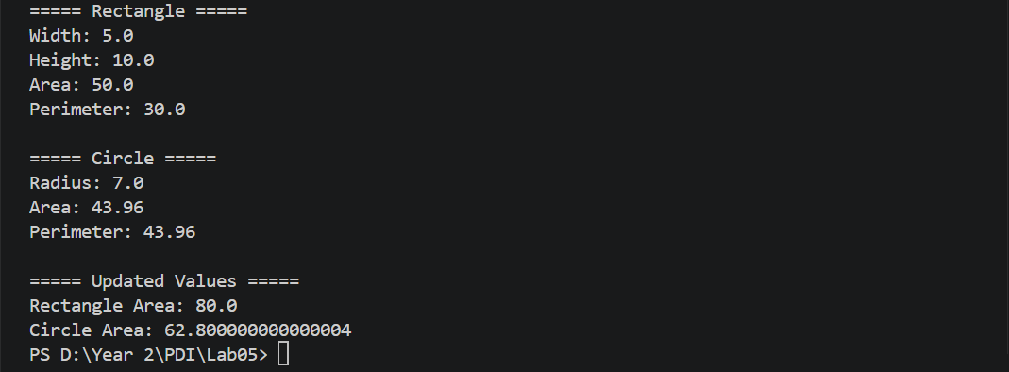
Practice 7:
Problem: Write a program that can creates and runs multiple threads using Thread class. Let’s define 3 functions to: find sum from 1 to n, show all prime numbers in between 1 to 100, and read data from a CSV file of student list (name, ID, age, gender) and store it into an array list.
Solution:
Student.java: Defines the structure of a student object.
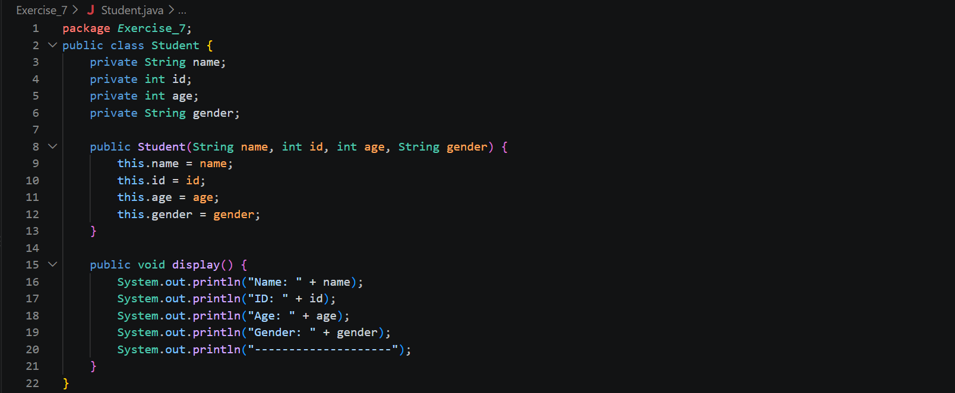

PrimeThread.java: Finds all prime numbers between 1 and 100.
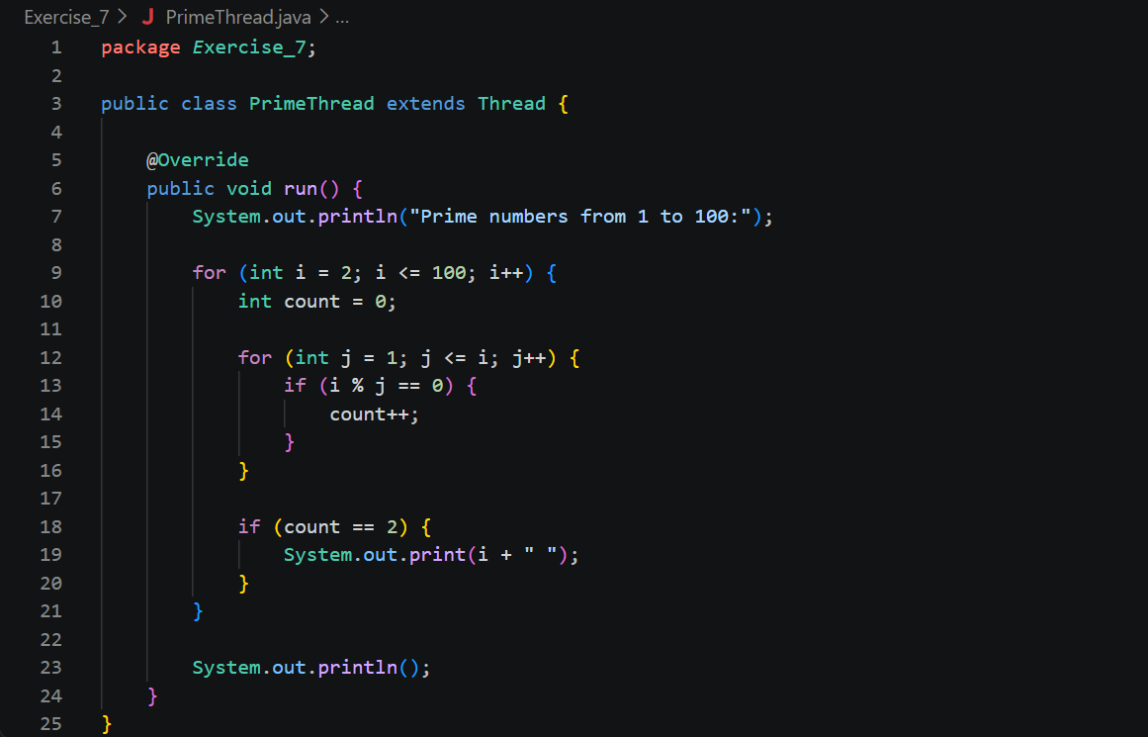
SumThread.java: Calculates the sum of numbers from 1 to a given number.
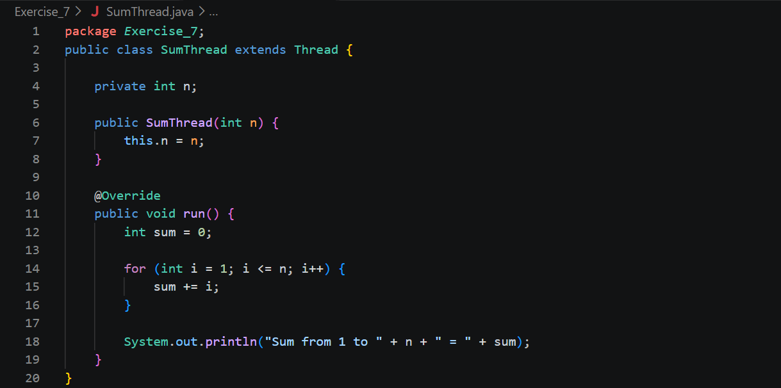
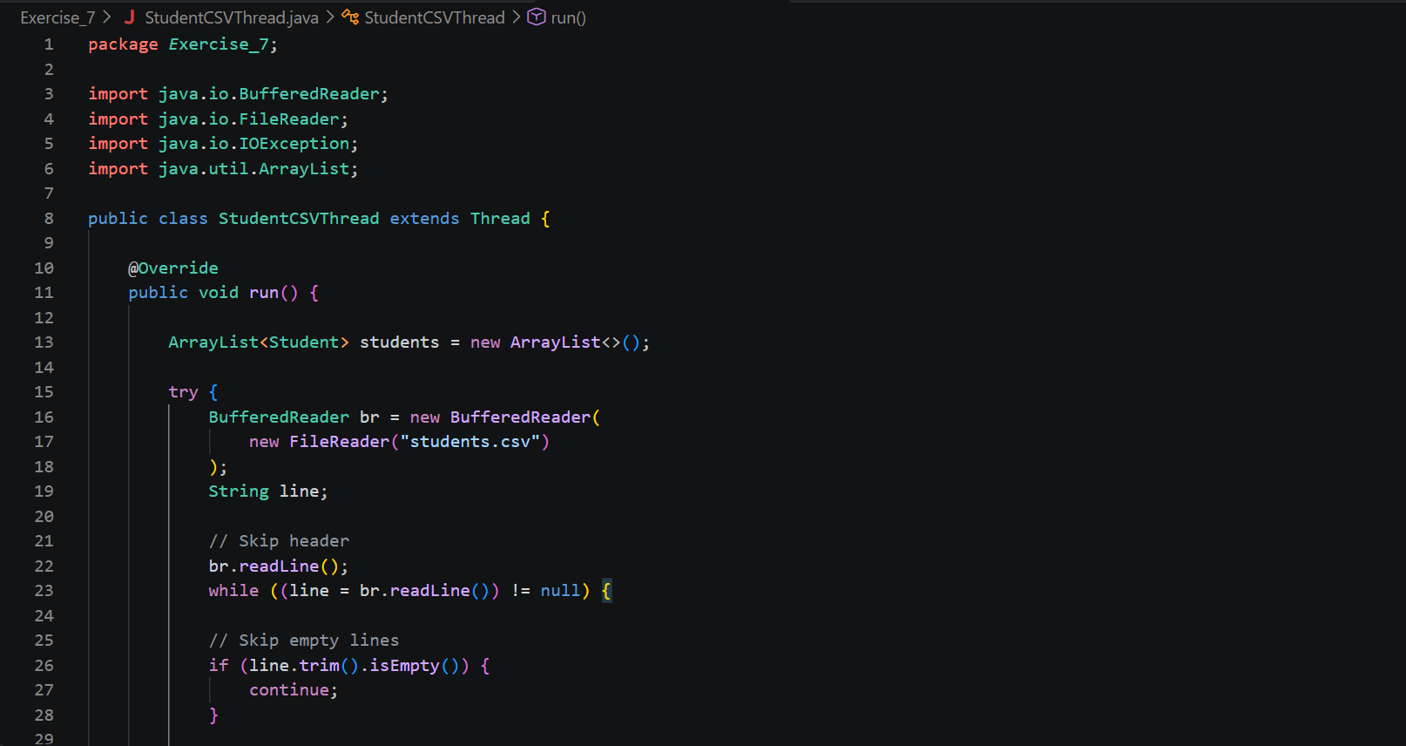
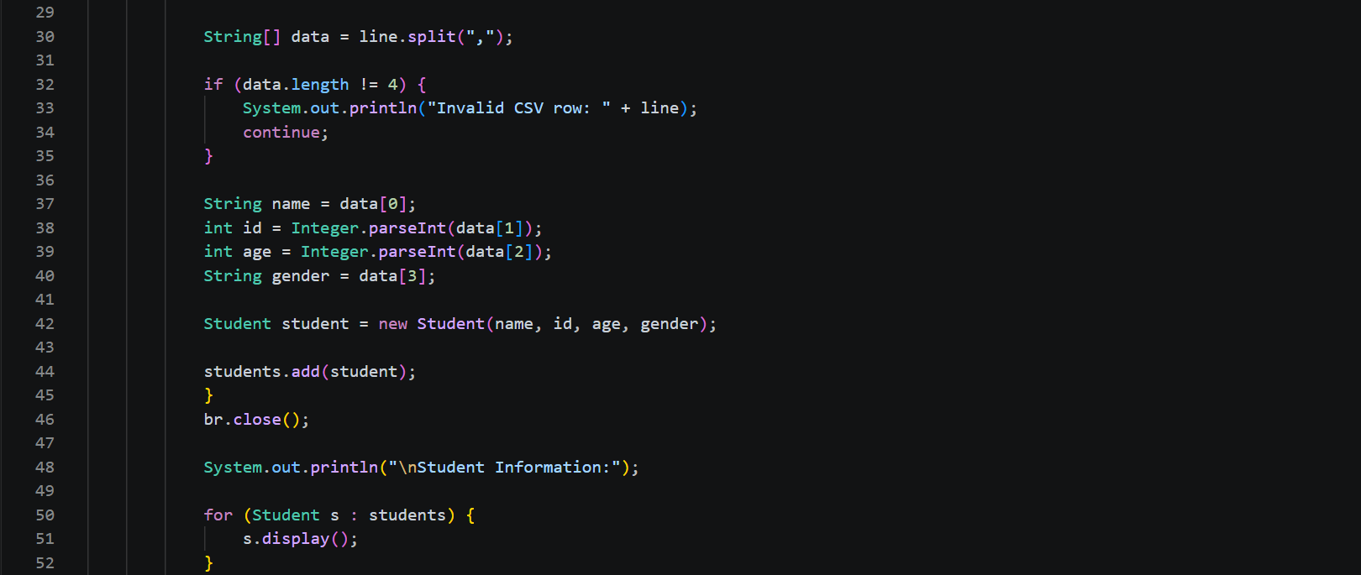
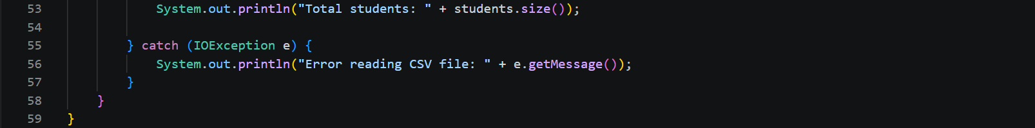
StudentCSVThread.java: Reads student information from students.csv and displays it.

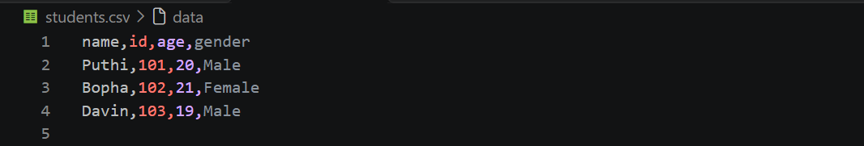
Student.csv: StudentCSVThread.java reads the file and processes its information.
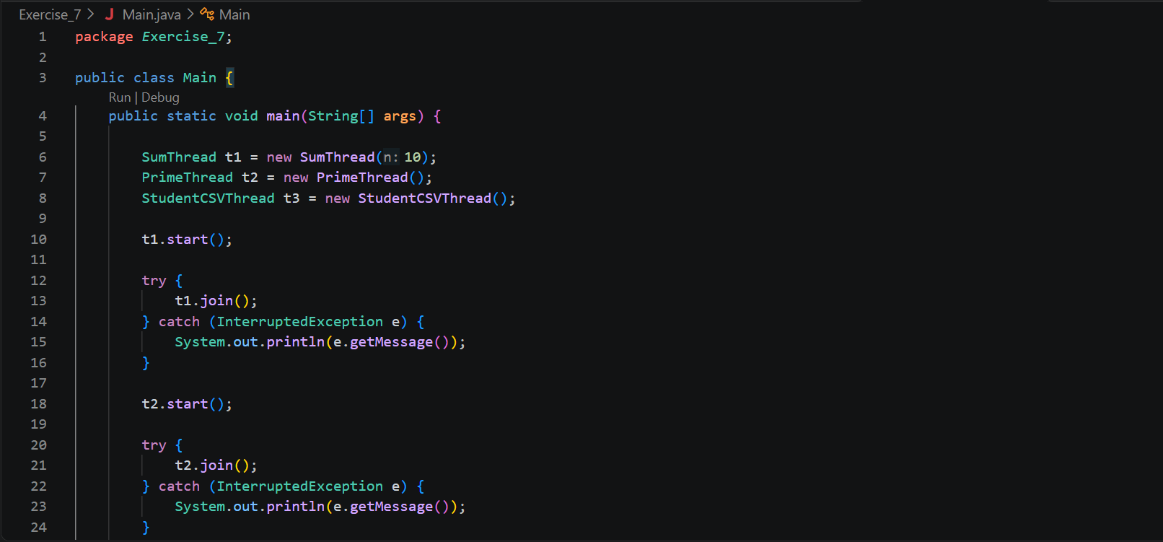
Main.java: Creates and starts the three threads.
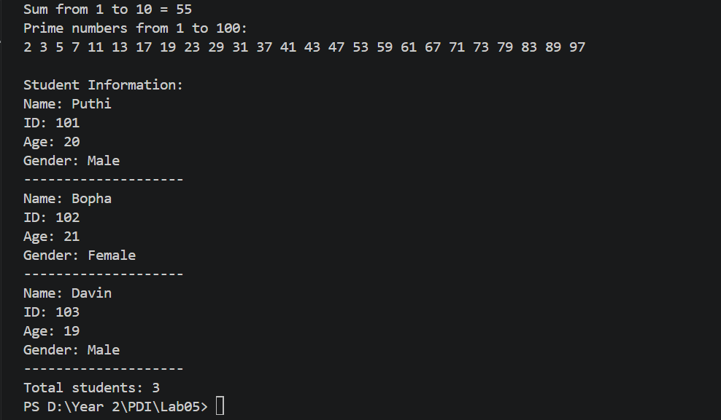
Output:
Practice 8:
Problem: Write a program that can creates and runs multiple threads using Thread class. Let’s define 3 functions to: find sum from 1 to n, show all prime numbers in between 1 to 100, and read data from a CSV file of student list (name, ID, age, gender) and store it into an array list.
Solution:
Student.java: Represents an individual student and stores their information.
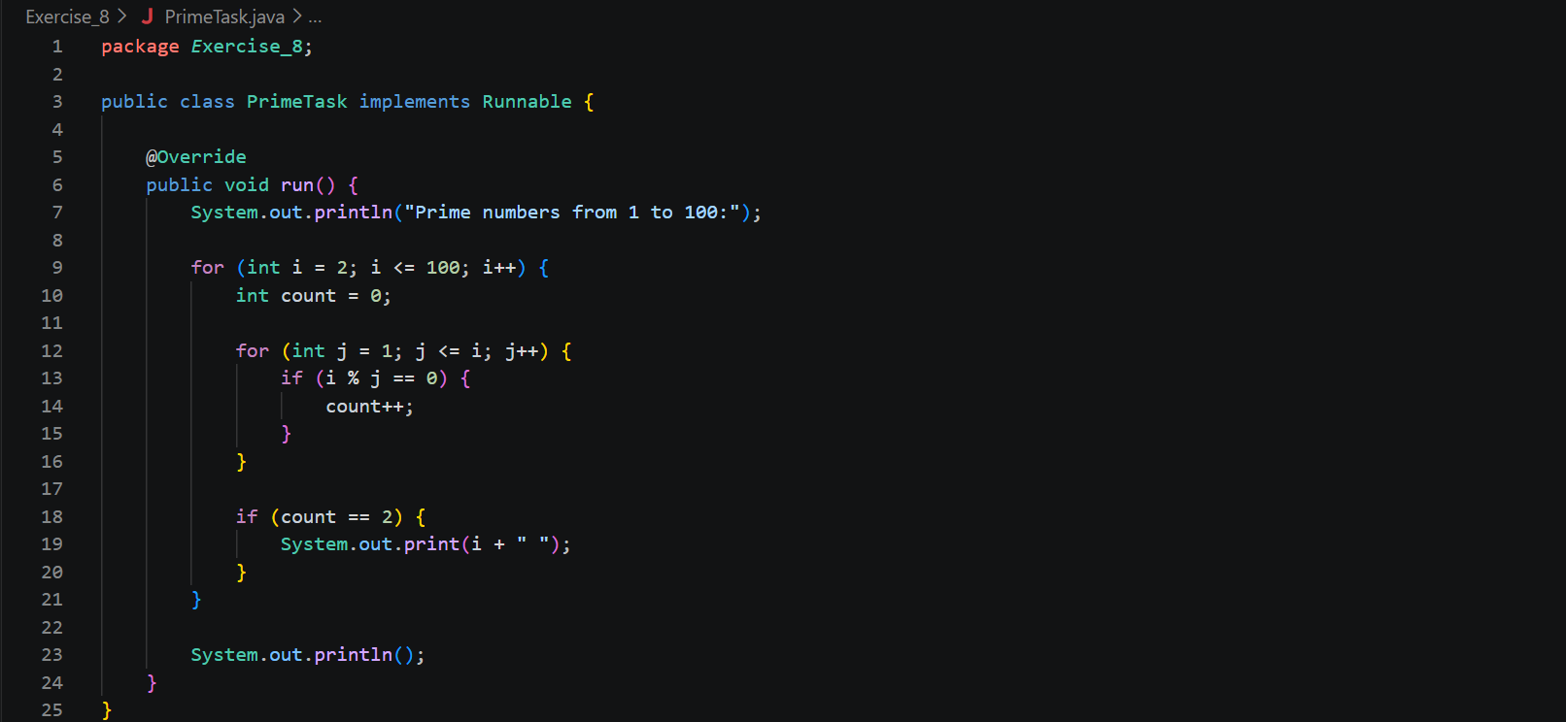
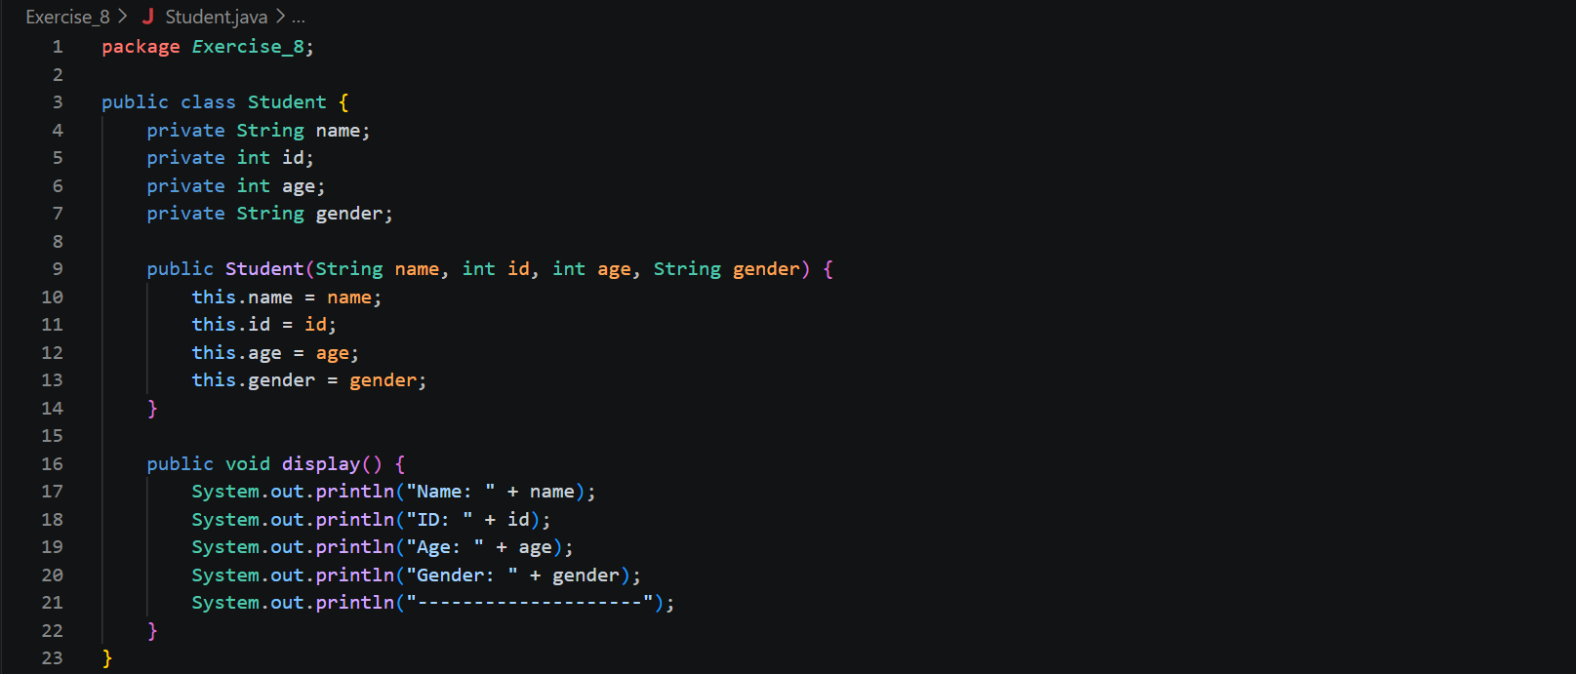
PrimeTask.java: Finds and displays prime numbers from 1 to 100.
SumTask.java: Calculates the sum of numbers from 1 to a given number.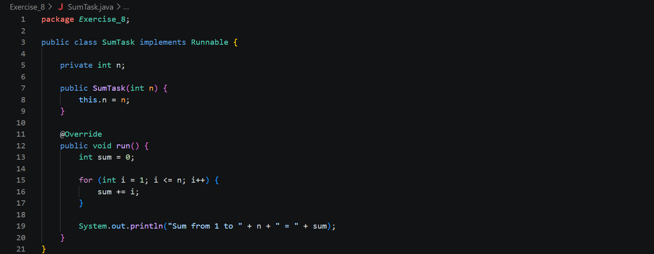
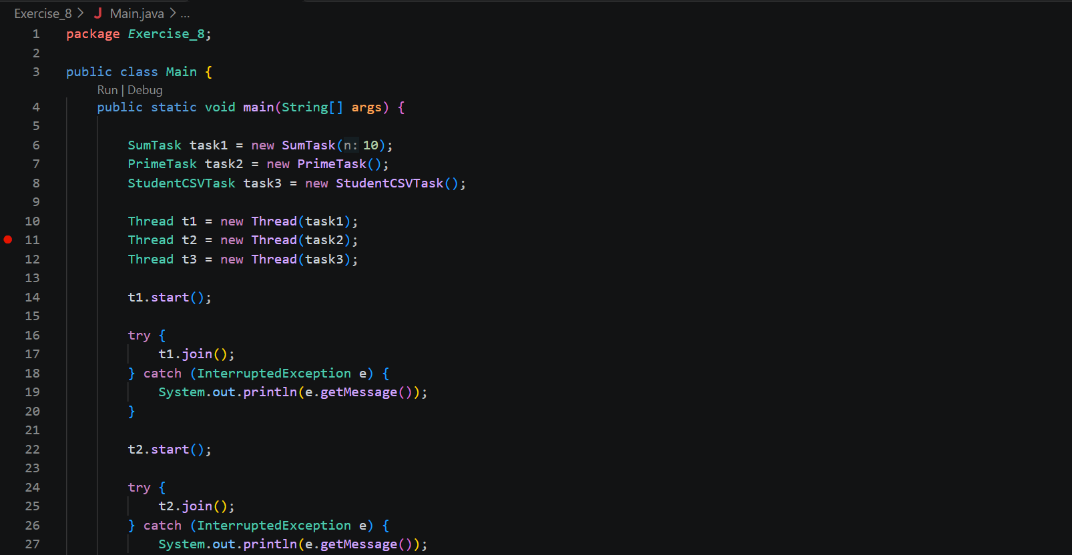
Main.java: Creates and controls the execution of three tasks using the Runnable interface.

Student.csv: StudentCSVThread.java reads the file and processes its information.
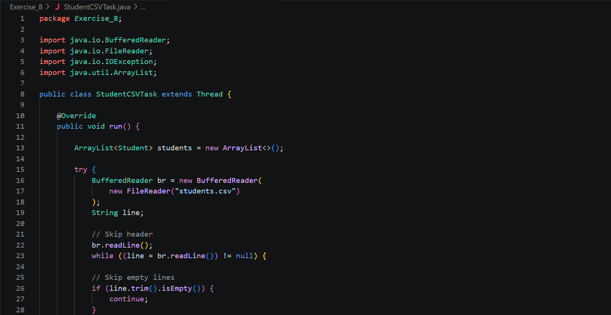
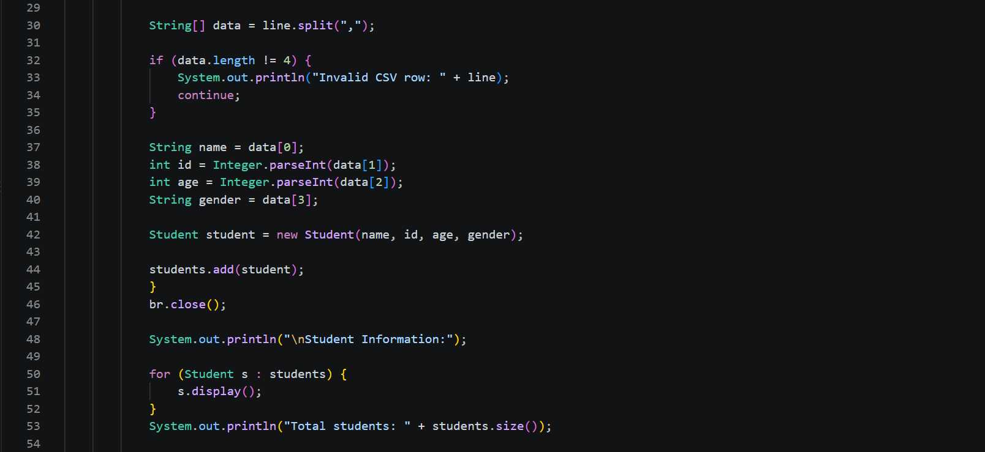
StudentCSVTask.java: Reads student information from students.csv and displays it.
Output:
Practice 9:
Problem: Write a functional program to:
a) find the cube of each number in a list and print the results
b) filter out positive numbers from a given list and print them.
c) sort data in a list.
Solution:
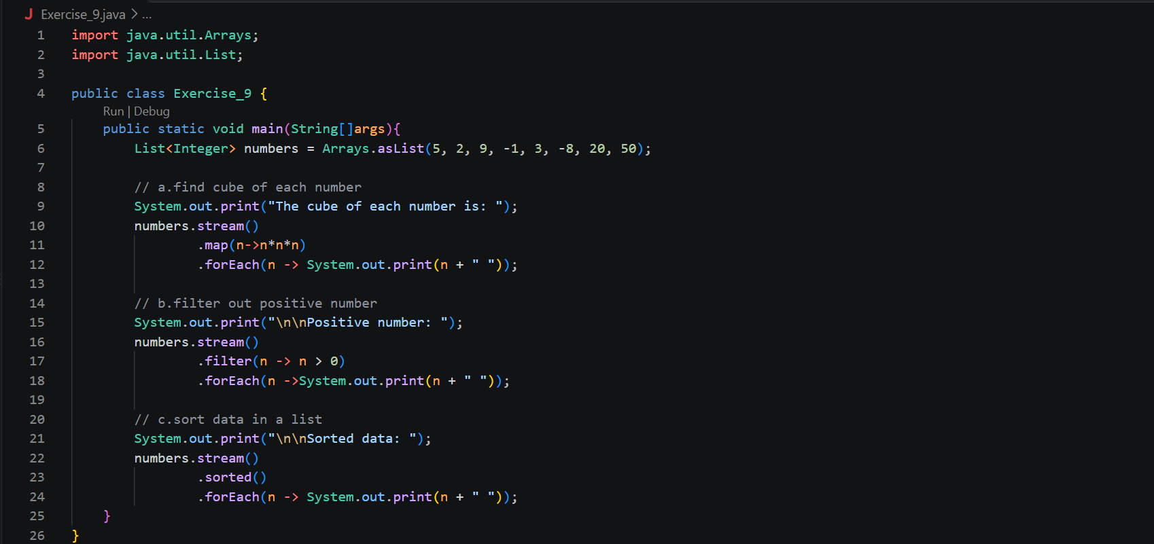
Output:
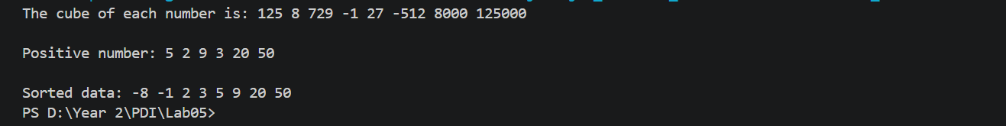Practice 10:
Problem: Read students' names from a CSV file, then display them in A-Z order.
Solution: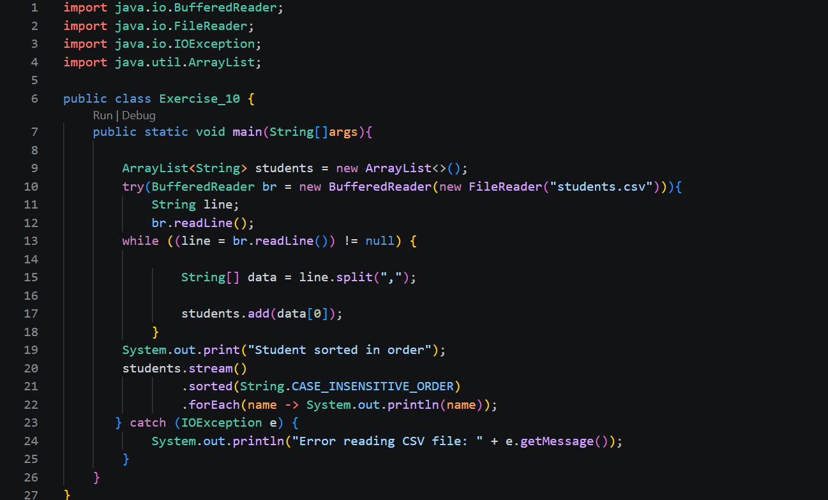
Output:
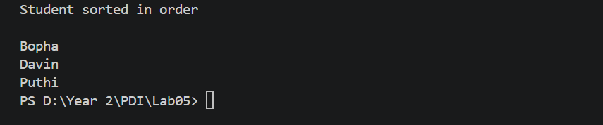
Practice 11:
Problem: Find max and min in an array using functional programming.
Solution:
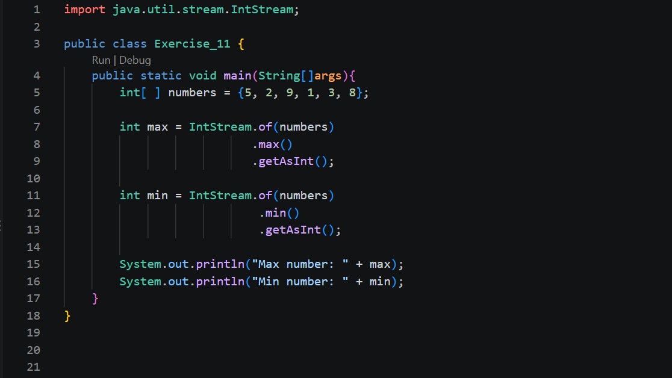
Output:
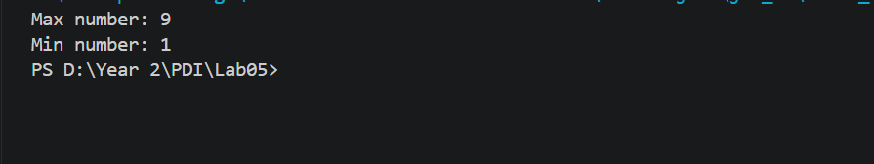

THE END

